 

University of Mumbai

**DEPARTMENT OF COMPUTER SCIENCE**

**JOURNAL**

**M. Sc. (Computer Science) (NEP) Semester-I**

2025-2026

Robotics

Elective

Submitted by

**Sanika Sanjay Patole**

Seat No. **CS251028**

 

University of Mumbai

**DEPARTMENT OF COMPUTER SCIENCE**

**CERTIFICATE**

This is to certify that the work entered in this journal was done in the Department of Computer Science, University of Mumbai by Ms. **Sanika Sanjay Patole**

Seat No.**CS251028** for the course of **M.Sc. (Computer Science) (NEP) Semester-I** during the academic year **2025-26** in a satisfactory manner.

__________________________ __________________________

Subject In-charge Head

Department of Computer Science Department of Computer Science

__________________________

External Examiner

**INDEX**

|  |  |  |  |
| --- | --- | --- | --- |
| **Sr no** | **Name** | **Date** | **Signature** |
| **1** | **Making a Raspberry Pi headless, and reaching it from the network using Wi-Fi and SSH** | **29-12-2025** |  |
| **2** | **Using sftp upload files from PC** | **29-12-2025** |  |
| **3** | **Write Python code to test motors** | **29-12-2025** |  |
| **4** | **Write a script to follow a predetermined path** | **04-12-2025** |  |
| **5** | **Develop Python code for testing the sensors.** | **05-12-2025** |  |
| **6** | **Add pan and tilt service to the robot object and test it** | **05-12-2025** |  |
| **7** | **Create an obstacle avoidance behaviour for robot and test it.** | **07-12-2025** |  |
| **8** | **Detect faces with Haar cascades** | **05-12-2025** |  |
| **9** | **Use the robot to display its camera as a web app on a phone or desktop, and then use the camera to drive smart colour and face-tracking behaviours** | **29-12-2025** |  |
| **10** | **Use a Raspberry Pi to run the Mycroft environment and connect it to a speaker/microphone combination** | **29-12-2025** |  |

**Practical 1**

**Aim: Making Raspberry pi headless, and reaching it from the network using Wi-Fi and SSH.**

**STEP I : Download raspberry pi imager for windows. And connect sd card to laptop.**

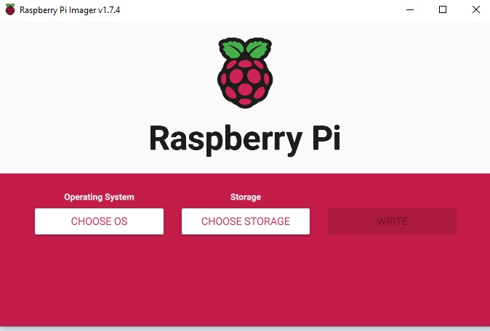

**STEP II : Select operating sysyem (raspberry pi OS 32-bit)**

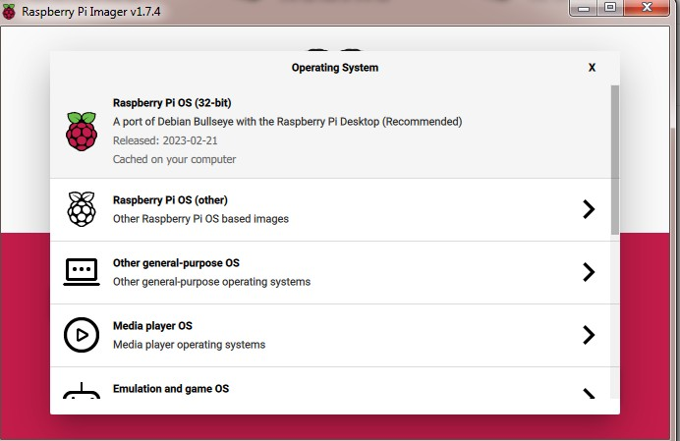

**STEP III : Select Storage.**

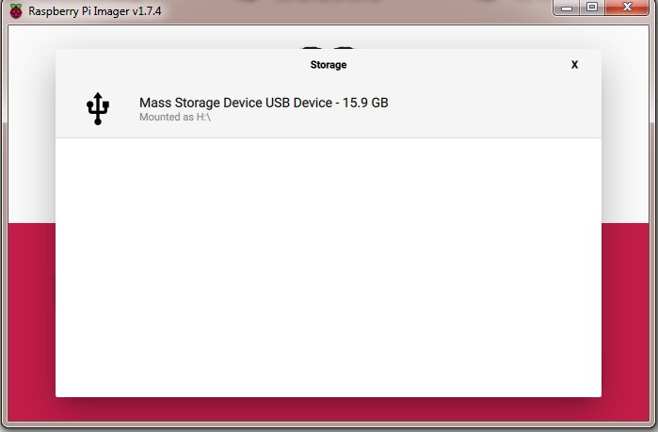

**STEP IV : Click on Setting Icon . and set hostname. Click to enable SSH.**

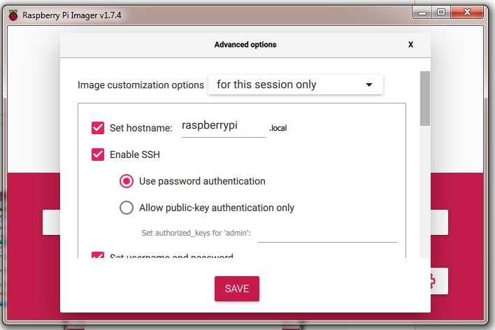

**STEP V : Click to configure wireless LAN. And select country.**

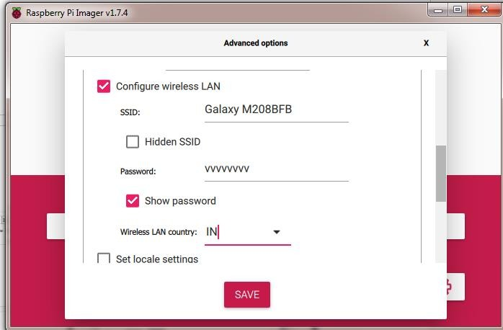

**STEP VI : Click to save.**

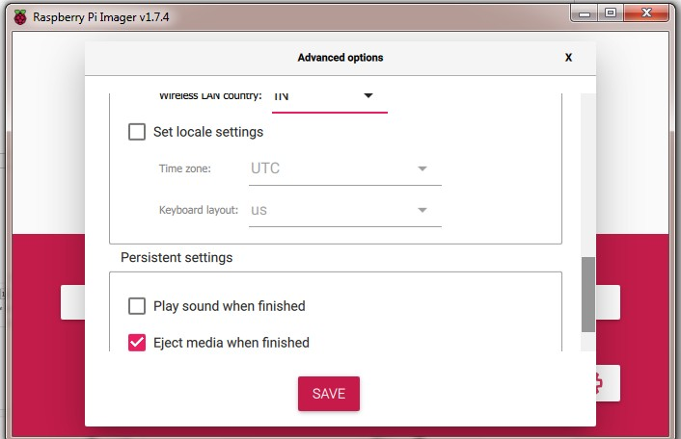

**STEP VII : Click on write.**

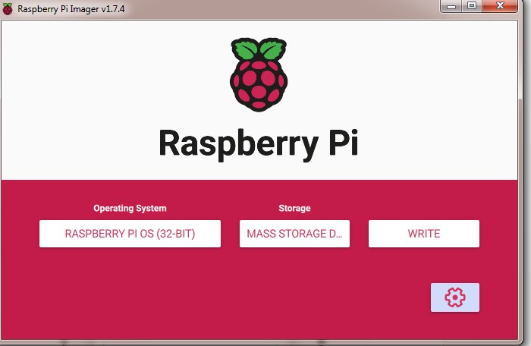

**STEP VIII : Click on yes.**

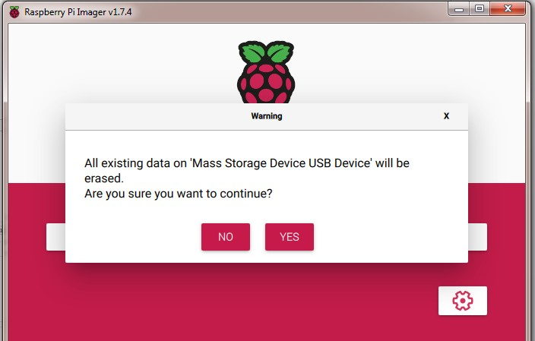

**STEP IX : Verifying raspberry pi .**

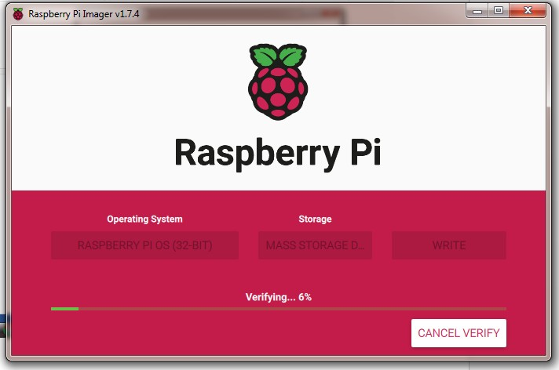

**STEP X : Click on continue .**

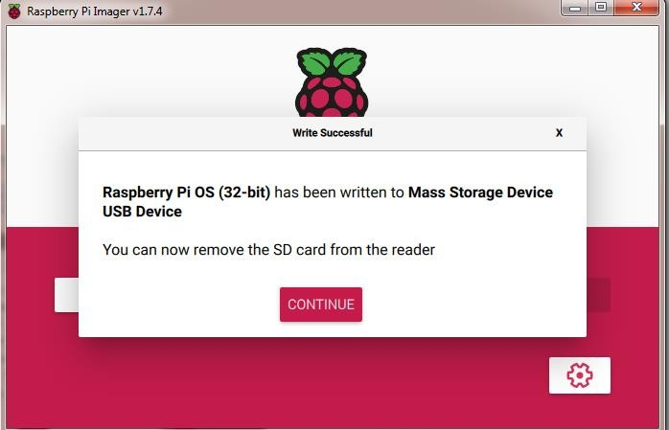

**Step XI : check the connection in your mobile hotspot of raspberrypi**

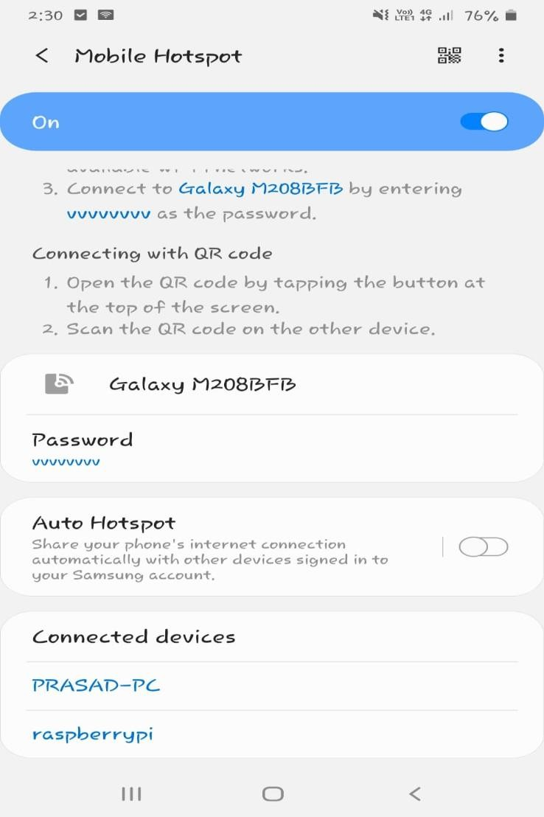

**STEP X: On cmd promt execute these command :**

1. **ping raspberrypi**
2. **ssh admin@raspberrypi**

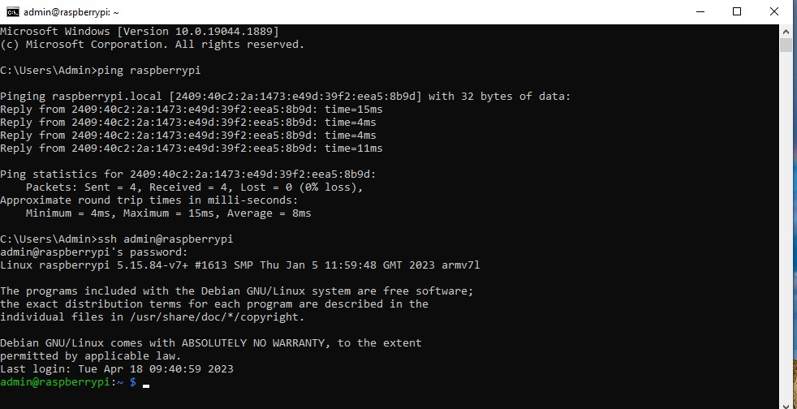

# **Practical 2**

# **Aim: Using sftp upload files from PC.**

**Step 1: Install the Raspberry Pi Imager**





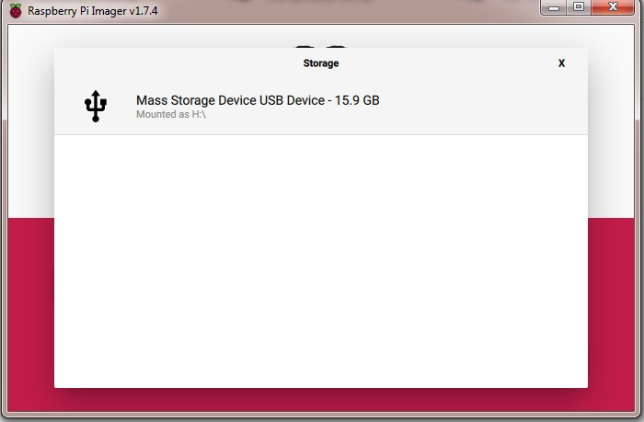

**Step 2: Set Host Name , enable SSH, Set Username and Password.**



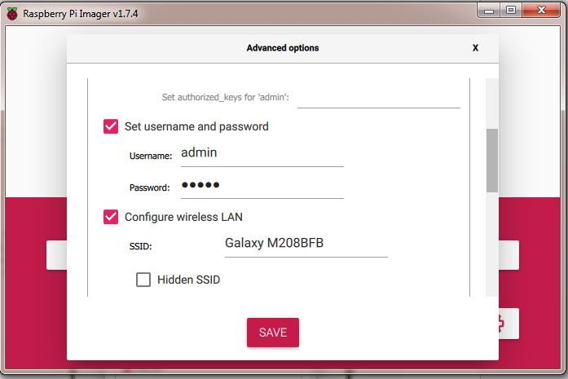

**Step 3: Set SSID and Password of hotspot which is used .**

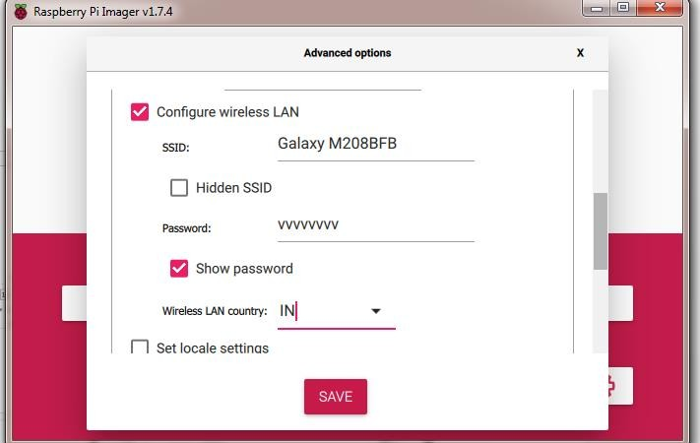

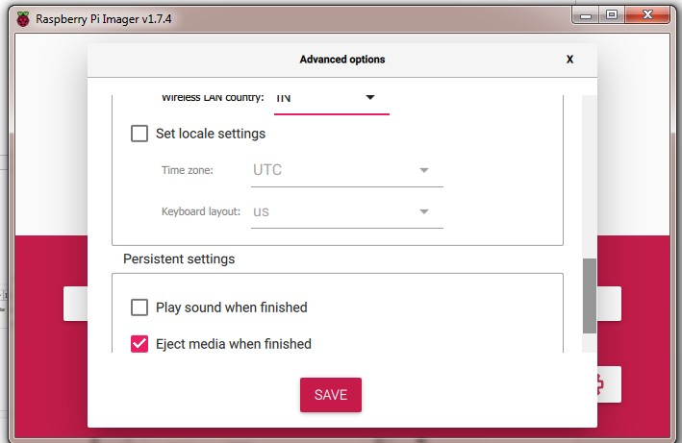

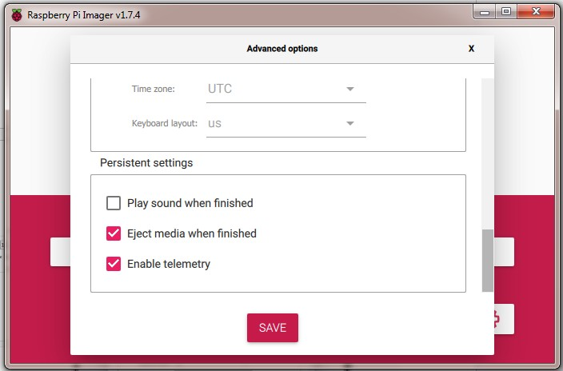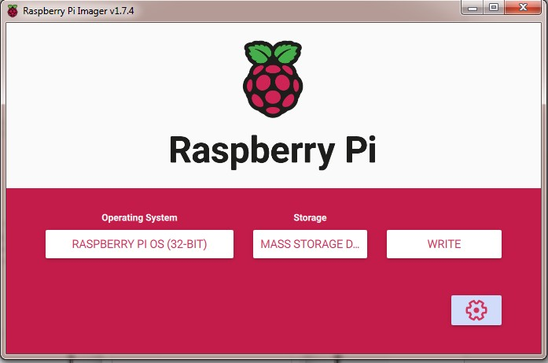

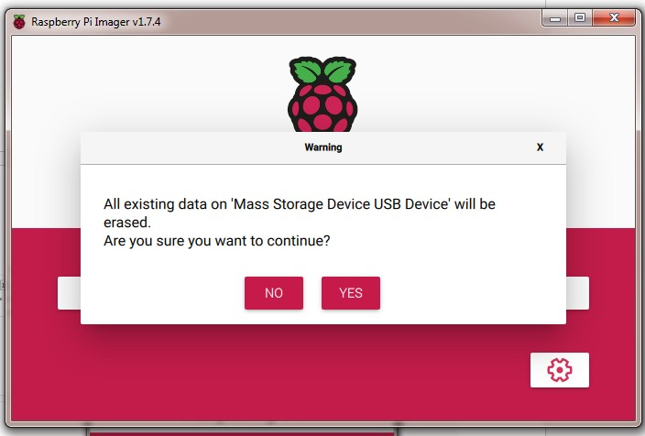

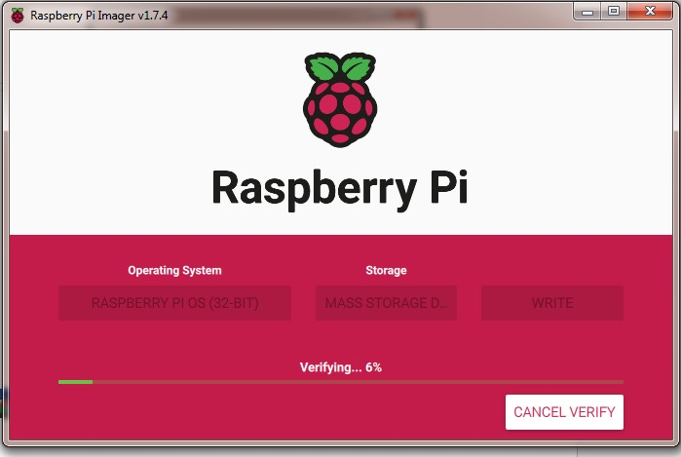

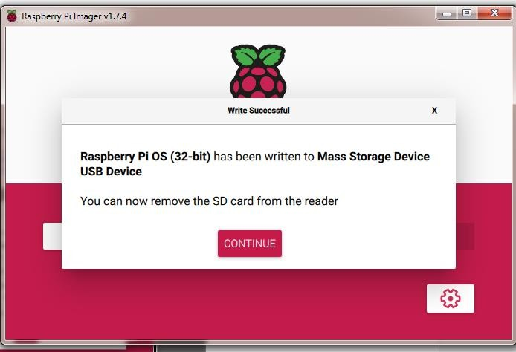

**Step 4: Connect Raspberry Pi WIFI and Laptop WIFI to Mobile Device.**

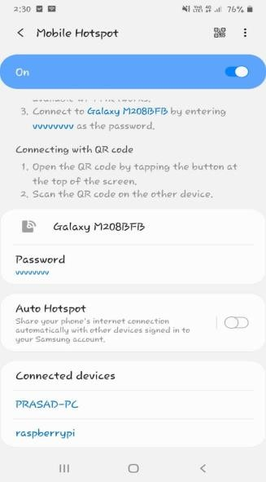

**Step 5: Open CMD and type following command**

**I ) ping raspberrypi or ping 162.168.207.244**

**II) ssh admin@ raspberrypi or ssh admin@ 162.168.207.244 And type password of Admin**

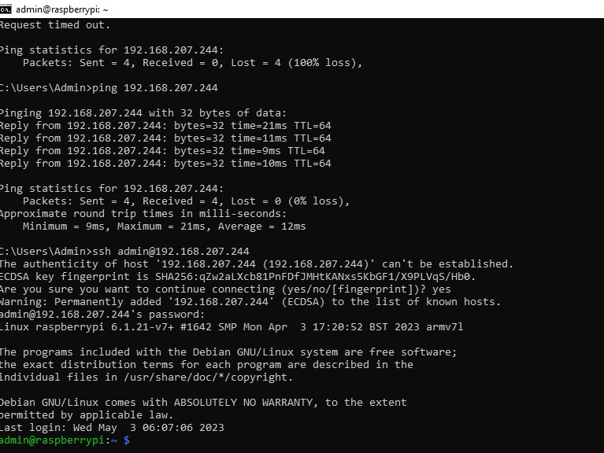

**Step:6 Download the FileZilla (Client)**

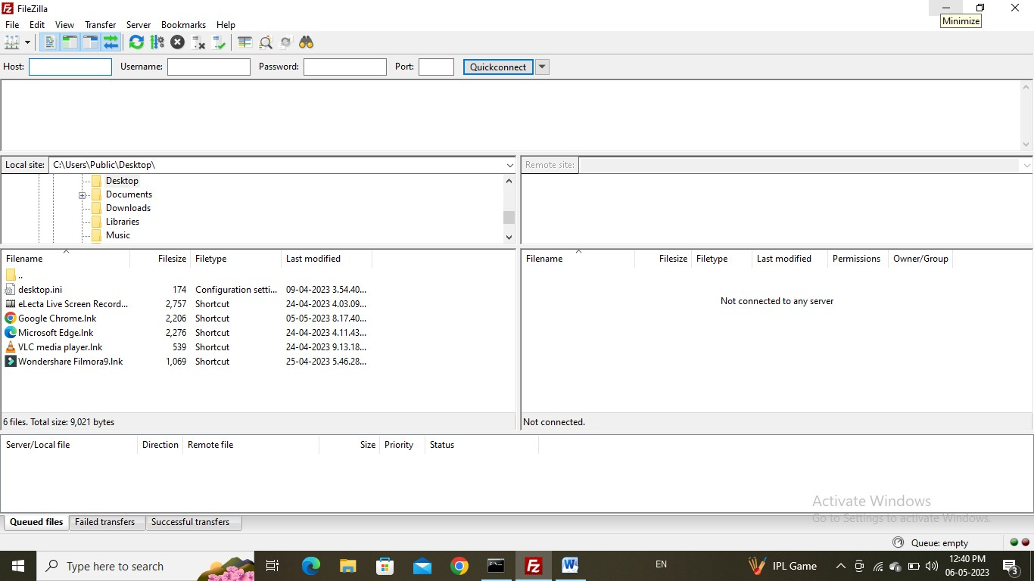

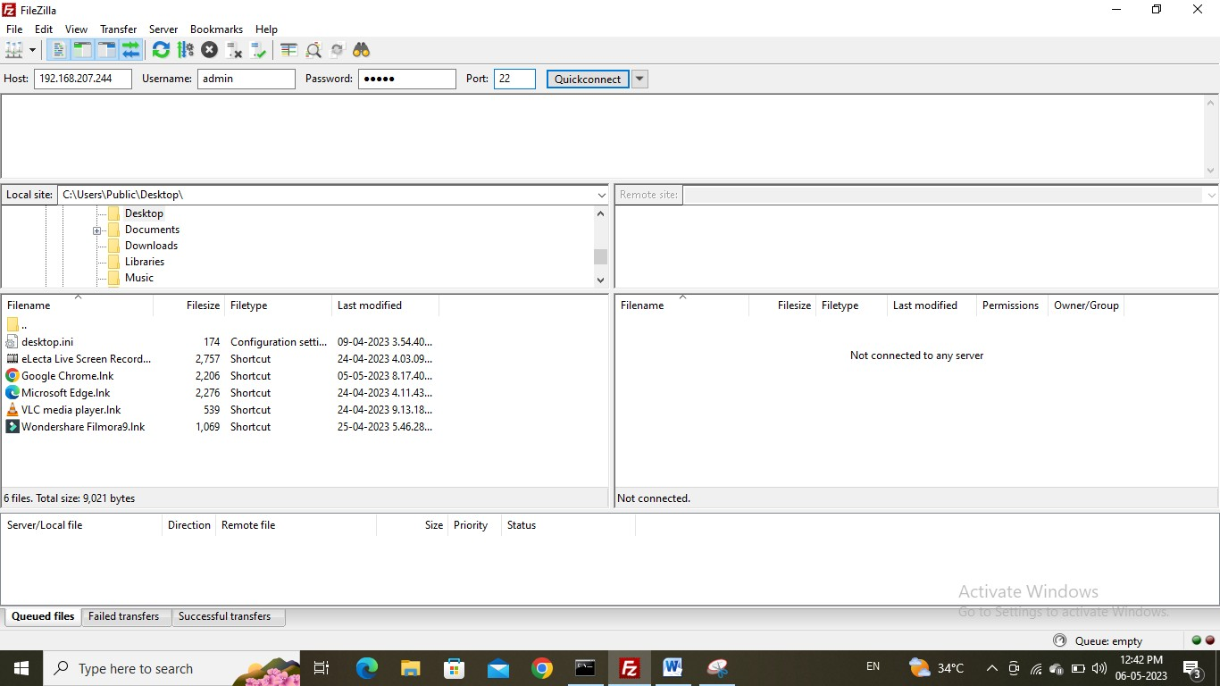

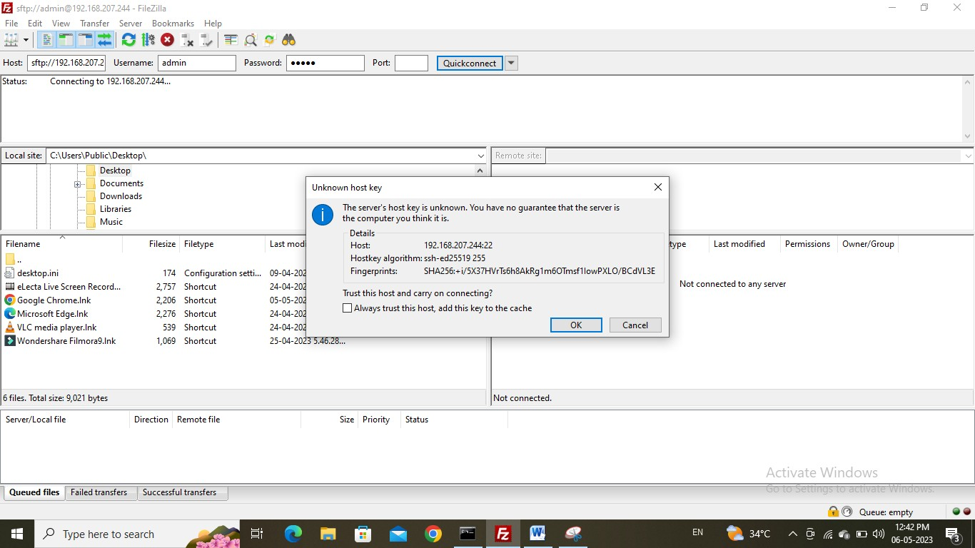

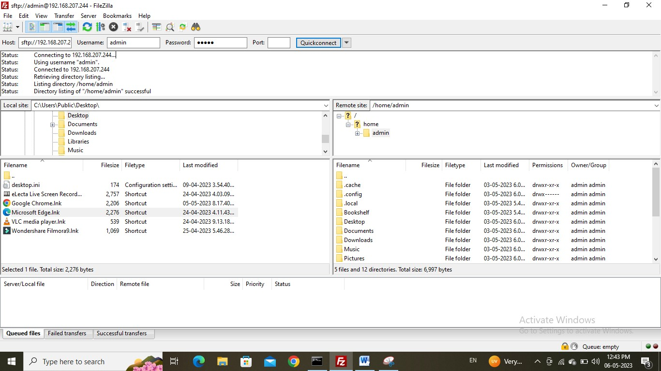

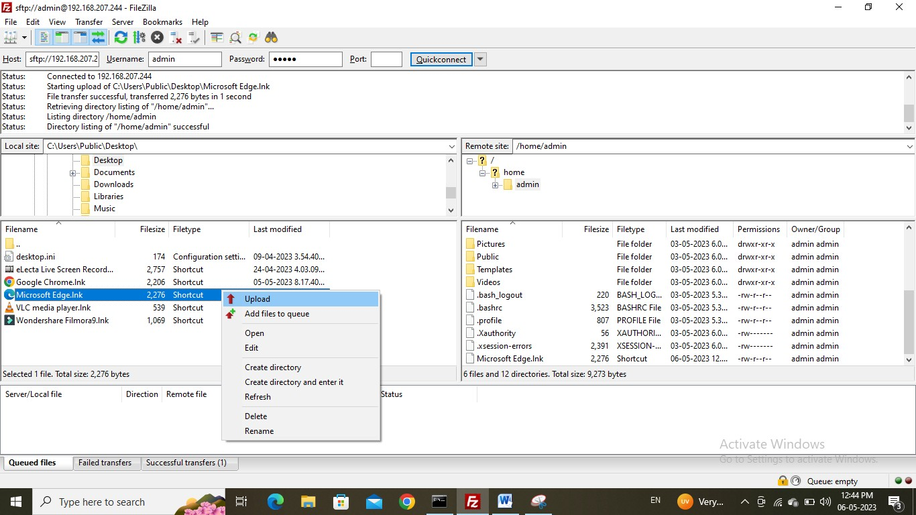

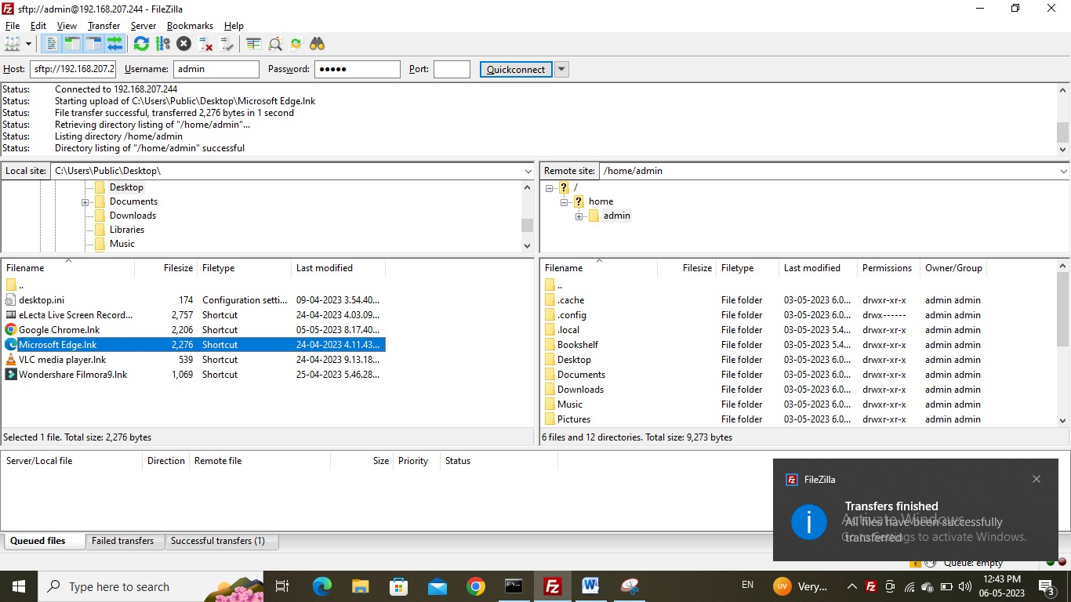

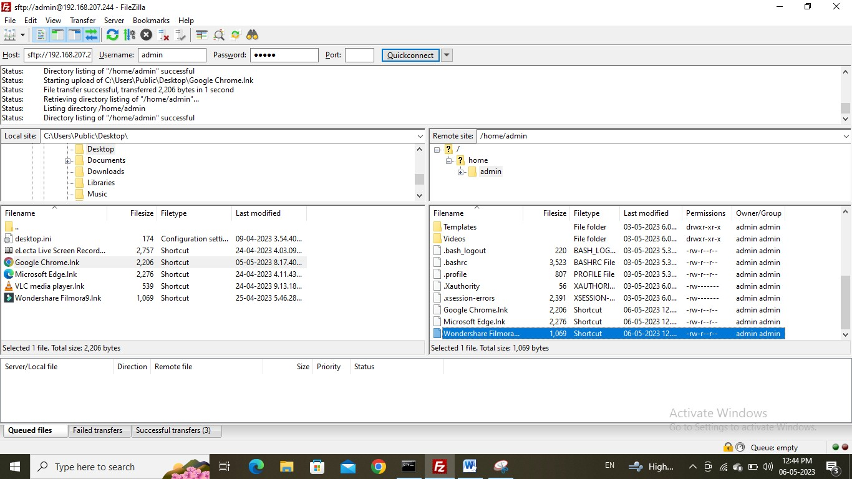

**Practical No: 03**

**Aim: Write python code to test motors**

**Give project name.**

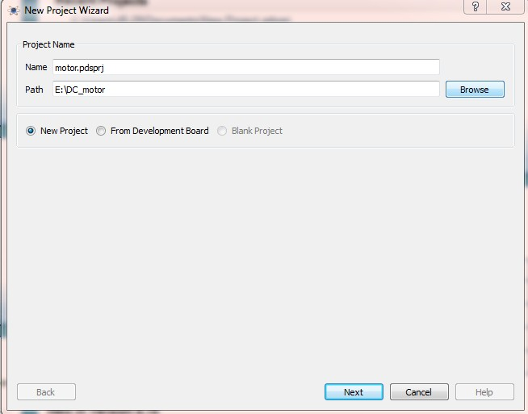

**Select “create a schematic from the selected template”.**

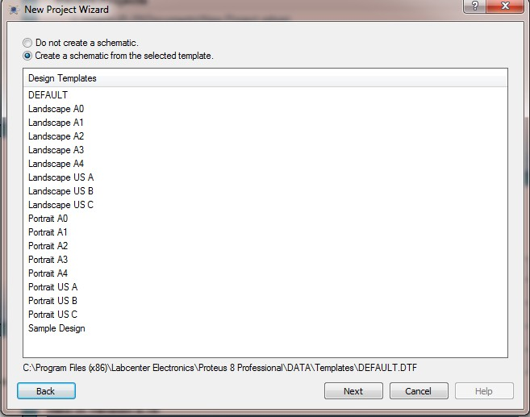

**Select “Do not create a PCB layout”**

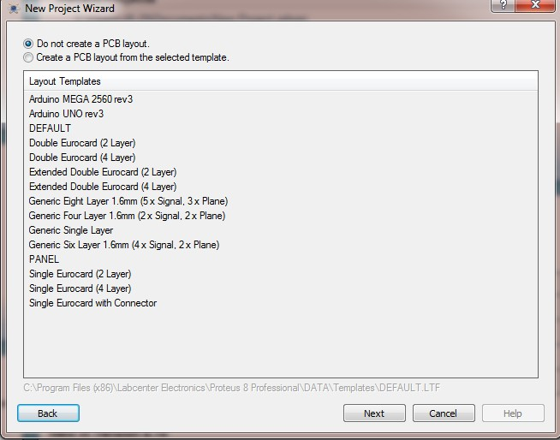

**Select “Create firmware project”. and create firmware project in proteus and select Raspberry pi Family.**

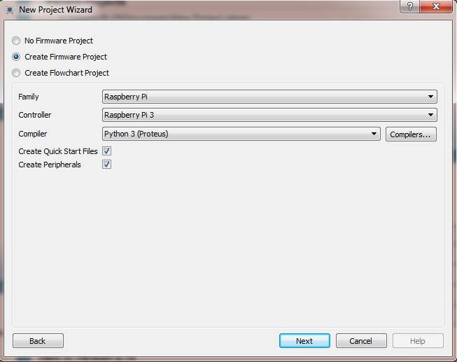

**Click on Finish.**

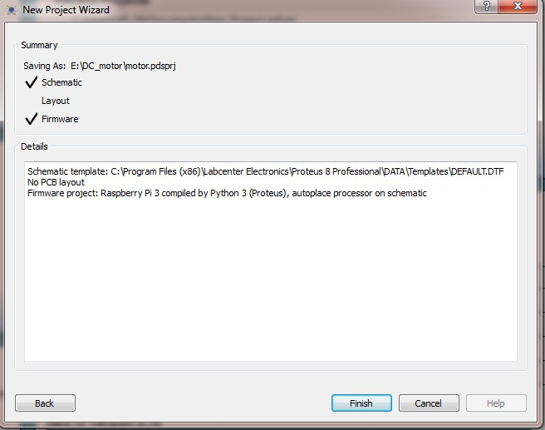

**Go to the library>pick devices>L293D**

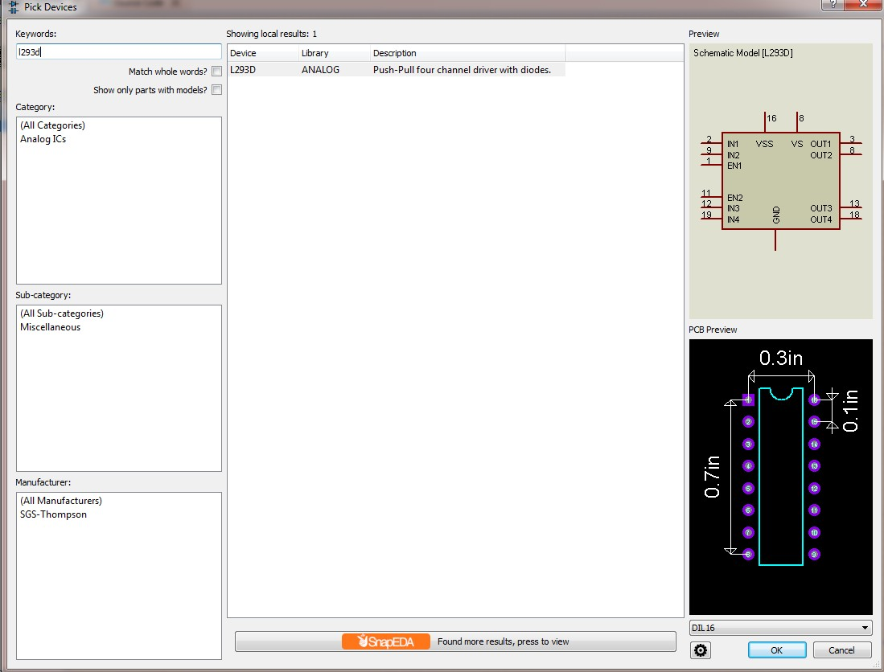

**Select MOTOR**

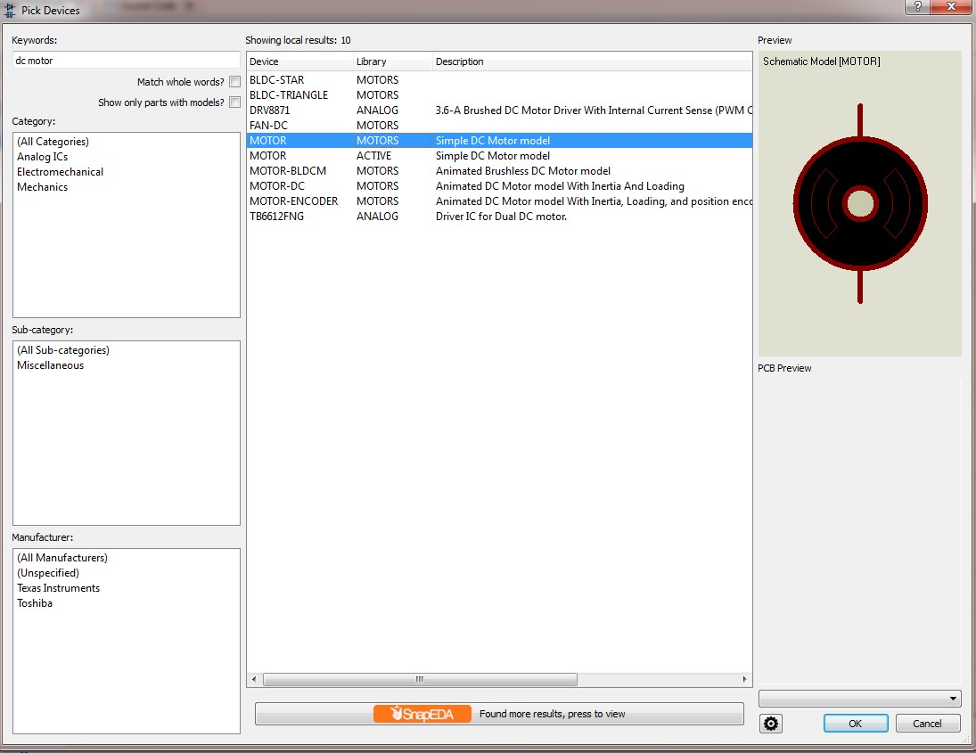

**Edit terminal label as GPIO4**

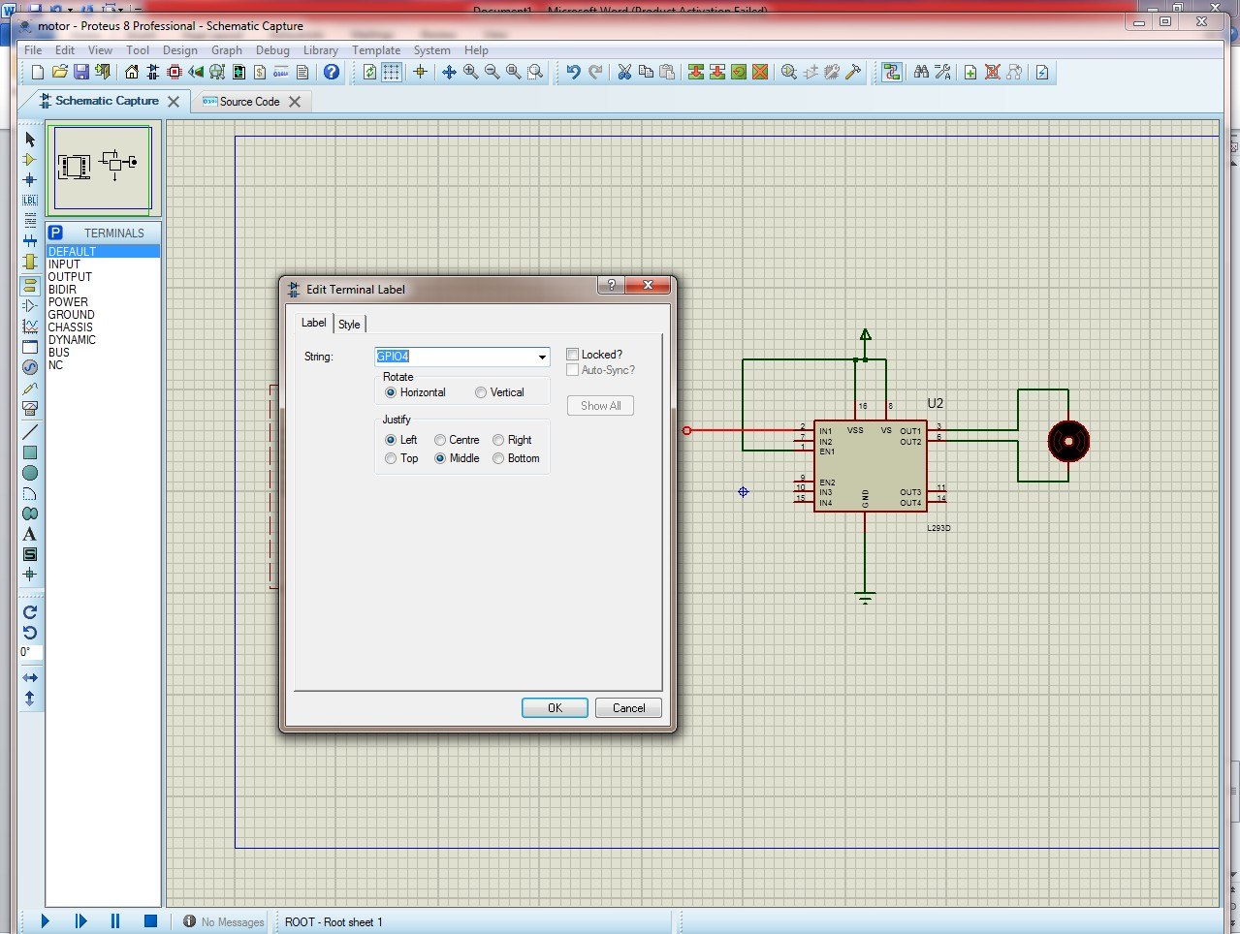

**Edit terminal label as GPIO17**

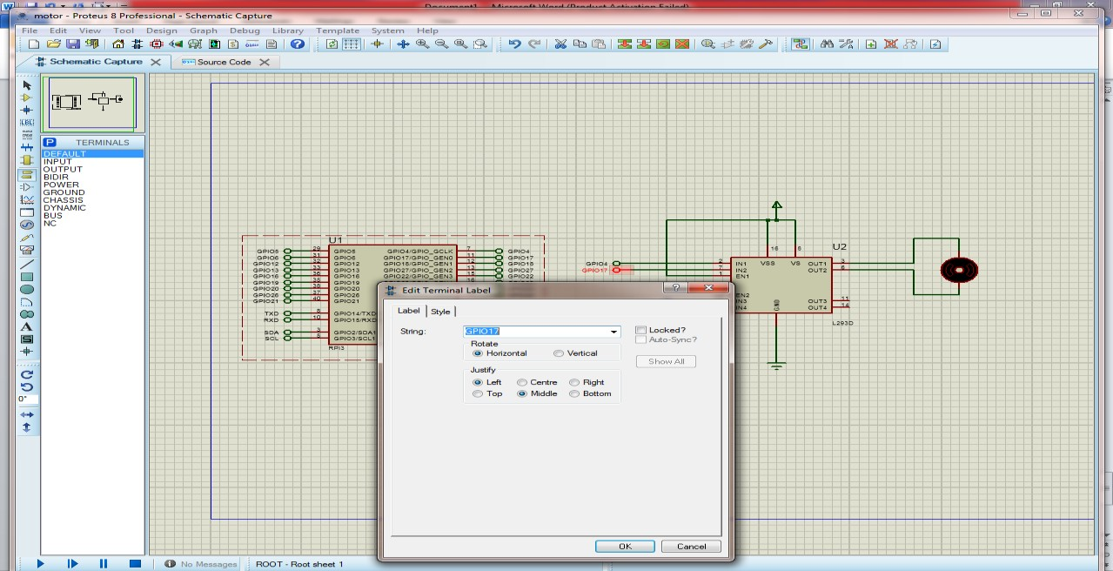

**Select BUTTON**

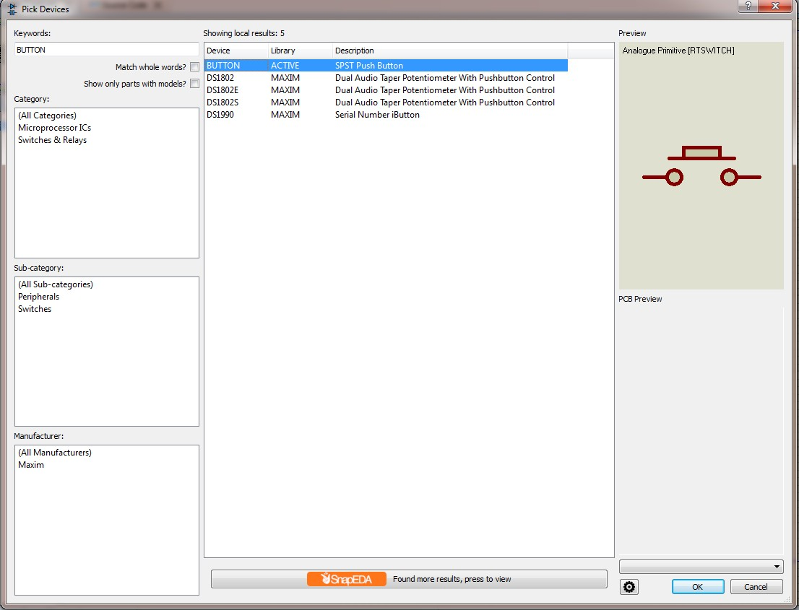

**Rotate button in clockwise**

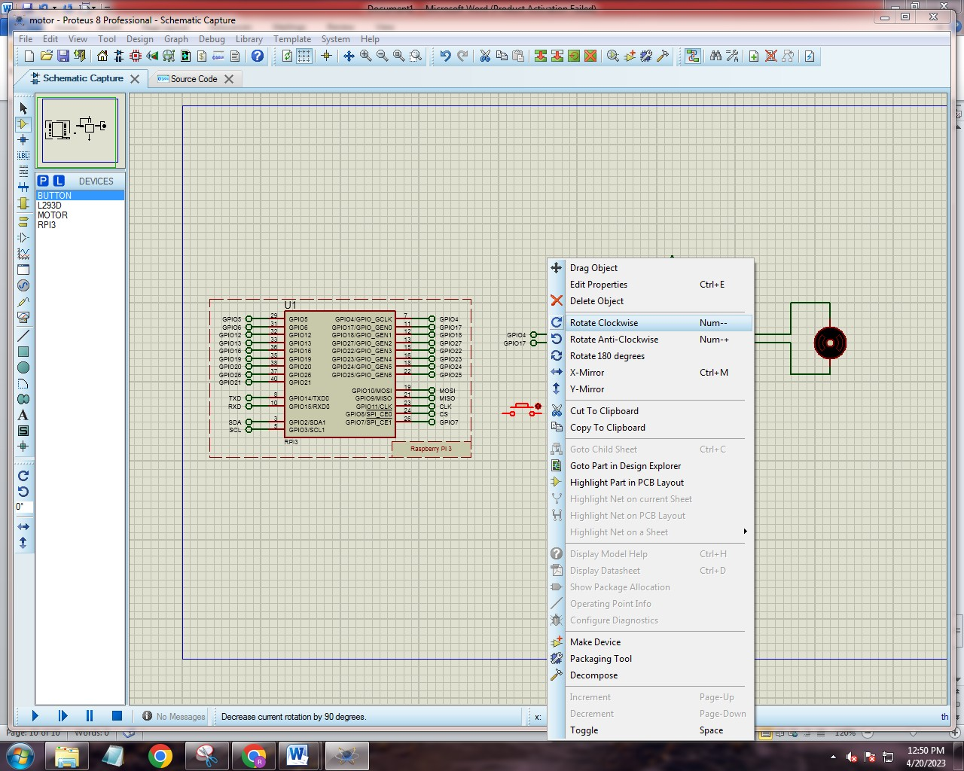

**Edit terminal label as GPIO18**

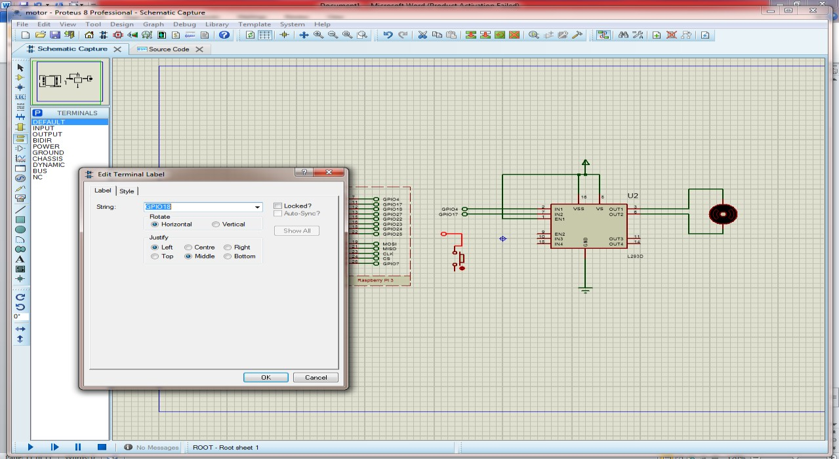

**Type code in proteus source code page**

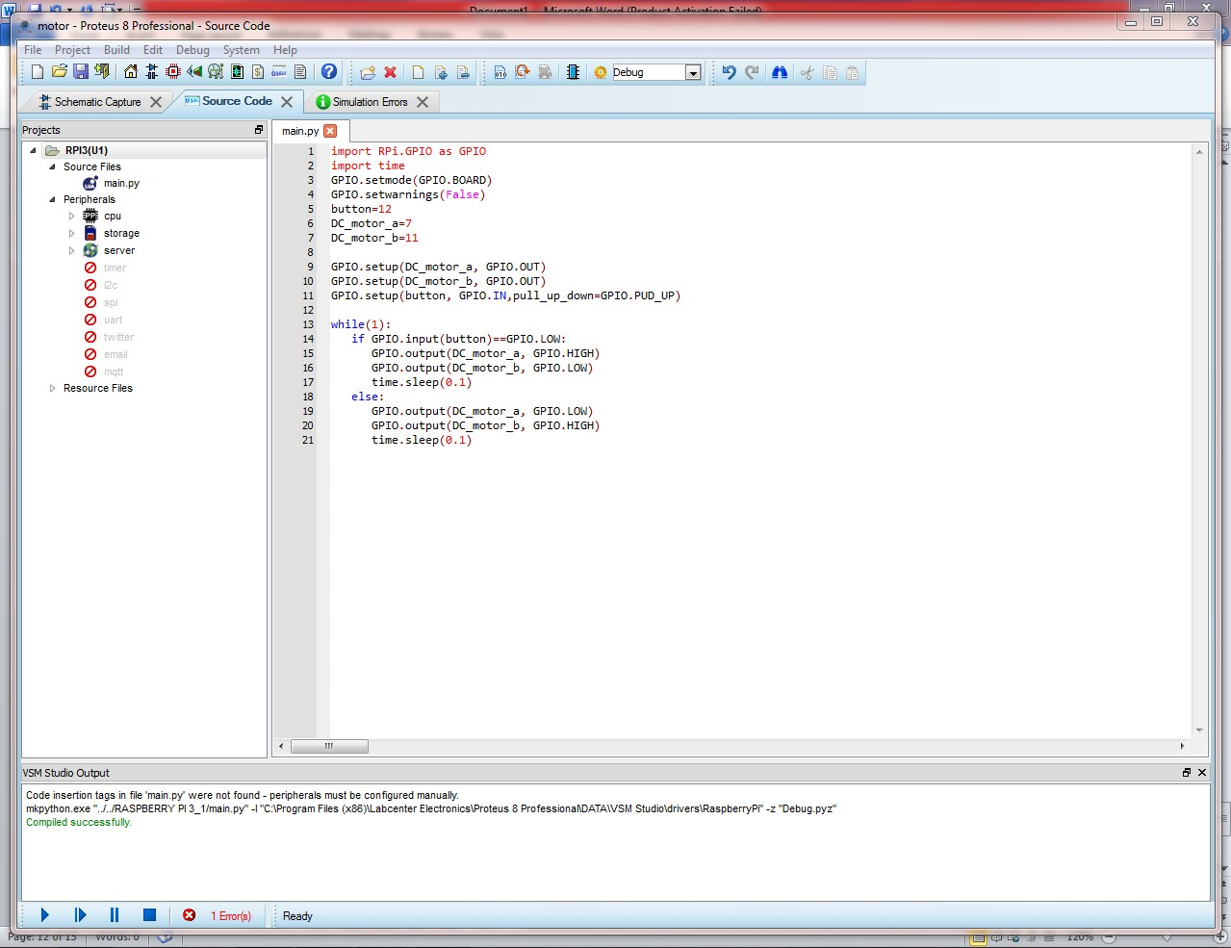

**Start Simulation**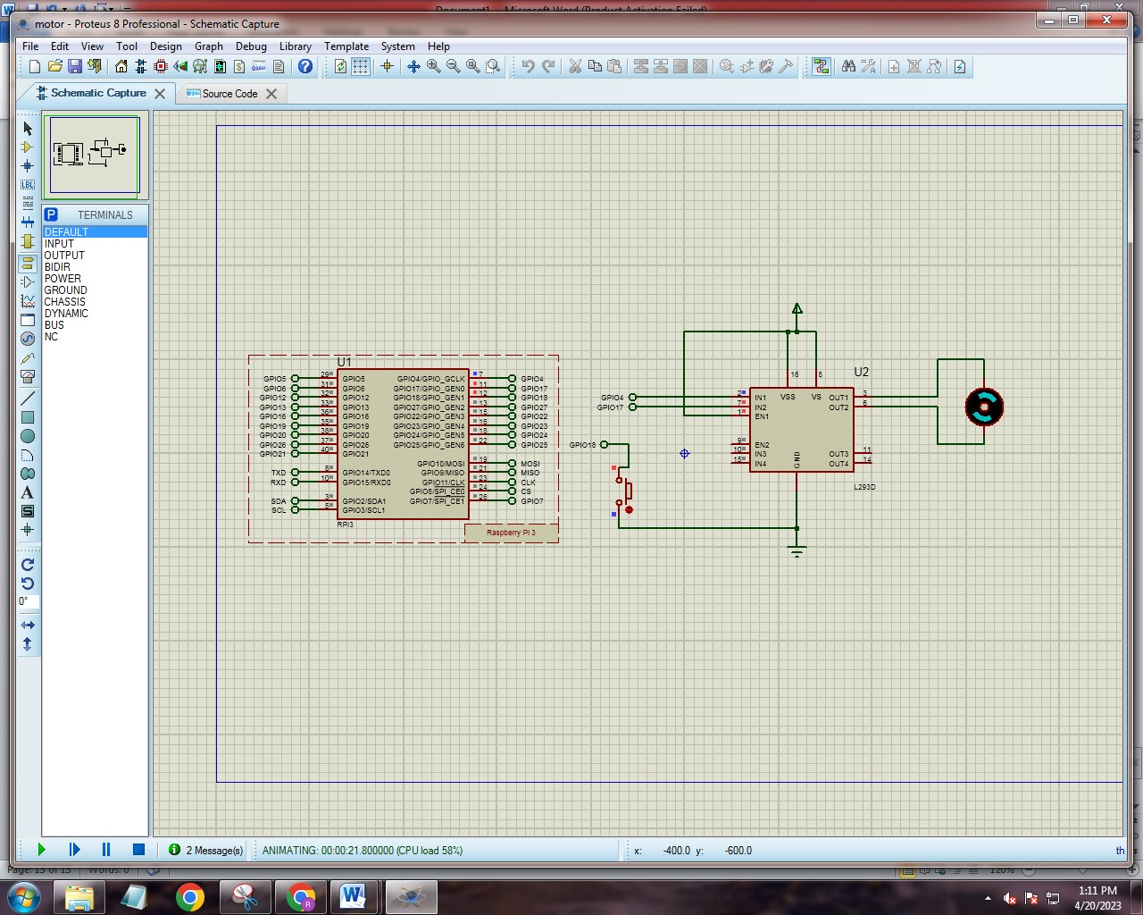

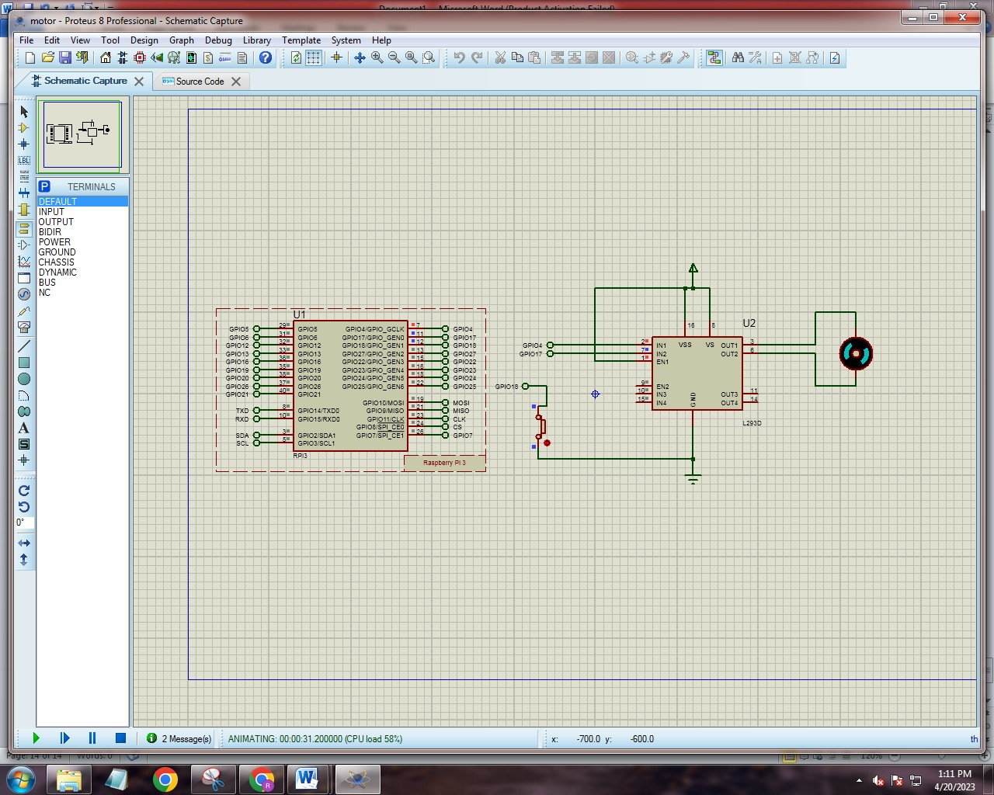

**PRACTICAL 4**

**Aim: Write a script to follow a predetermined path**

**CODE:**

**const int pingPin = 7;**

**const int red=11;**

**const int blue=10;**

**int green=9;**

**void setup() {**

**// initialize serial communication:**

**Serial.begin(9600);**

**pinMode(red,OUTPUT);**

**pinMode(blue,OUTPUT);**

**pinMode(green,OUTPUT);**

**}**

**void loop() {**

**// establish variables for duration of the ping, and the distance result**

**// in inches and centimeters:**

**long duration, inches, cm;**

**// The PING))) is triggered by a HIGH pulse of 2 or more microseconds.**

**// Give a short LOW pulse beforehand to ensure a clean HIGH pulse:**

**pinMode(pingPin, OUTPUT);**

**digitalWrite(pingPin, LOW);**

**delayMicroseconds(2);**

**digitalWrite(pingPin, HIGH);**

**delayMicroseconds(5);**

**digitalWrite(pingPin, LOW);**

**// The same pin is used to read the signal from the PING))): a HIGH pulse**

**// whose duration is the time (in microseconds) from the sending of the ping**

**// to the reception of its echo off of an object.**

**pinMode(pingPin, INPUT);**

**duration = pulseIn(pingPin, HIGH);**

**// convert the time into a distance**

**inches = microsecondsToInches(duration);**

**cm = microsecondsToCentimeters(duration);**

**Serial.print(inches);**

**Serial.print("in, ");**

**Serial.print(cm);**

**Serial.print("cm");**

**Serial.println();**

**if(inches<10){**

**digitalWrite(red,HIGH);**

**digitalWrite(green,LOW);**

**digitalWrite(blue,LOW);**

**}**

**else if (inches>10 && inches<50){**

**digitalWrite(red,LOW);**

**digitalWrite(green,LOW);**

**digitalWrite(blue,HIGH);**

**}**

**else{**

**digitalWrite(red,LOW);**

**digitalWrite(green,HIGH);**

**digitalWrite(blue,LOW);**

**}**

**}**

**long microsecondsToInches(long microseconds) {**

**// According to Parallax's datasheet for the PING))), there are 73.746**

**// microseconds per inch (i.e. sound travels at 1130 feet per second).**

**// This gives the distance travelled by the ping, outbound and return,**

**// so we divide by 2 to get the distance of the obstacle.**

**// See: http://www.parallax.com/dl/docs/prod/acc/28015-PING-v1.3.pdf**

**return microseconds / 74 / 2;**

**}**

**long microsecondsToCentimeters(long microseconds) {**

**// The speed of sound is 340 m/s or 29 microseconds per centimeter.**

**// The ping travels out and back, so to find the distance of the object we**

**// take half of the distance travelled.**

**return microseconds / 29 / 2;**

**}**

**OUTPUT**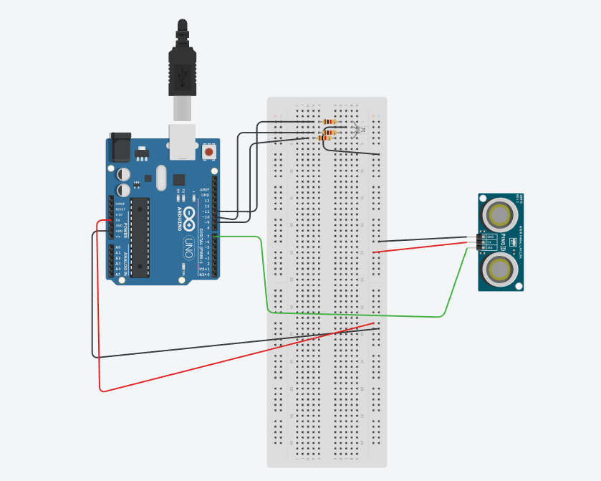

**PRACTICAL 5**

**Aim: Develop Python code for testing the sensors.**

**Step 1: Place the following component in TinkerCard.**

**Compontes:**

1. **PIR Sensor**
2. **Resistor**
3. **Piezo**
4. **Arduino Uno R3**
5. **LED RGB**

**Step 2:Type the following code**

**int pirsensor = 0;**

**void setup()**

**{**

**pinMode(A0, INPUT);**

**Serial.begin(9600);**

**pinMode(7, OUTPUT);**

**pinMode(6, OUTPUT);**

**pinMode(10, OUTPUT);**

**pinMode(10, OUTPUT);**

**}**

**void loop()**

**{**

**pirsensor = analogRead(A0);**

**Serial.println(pirsensor);**

**if (pirsensor >= 100) {**

**digitalWrite(7, LOW);**

**digitalWrite(6, HIGH);**

**tone(10, 92, 100); // play tone 30 (F#2 = 92 Hz)**

**} else {**

**digitalWrite(7, HIGH);**

**digitalWrite(6, LOW);**

**digitalWrite(10, LOW);**

**}**

**delay(10); // Delay a little bit to improve simulation performance**

**}**

**OUTPUT**

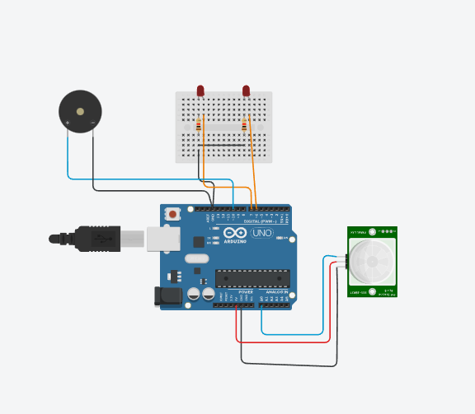

**PRACTICAL 6**

**Aim: Add pan and tilt service to the robot object and test it**

**CODE**

**Aim: Add pan and tilt service to the robot object and test it.**

**Take Arduino Uno R3 , Breadboard, two Servo motor and make connections:**

**Take two potentiometer and change resistance to 10: Join wires:**

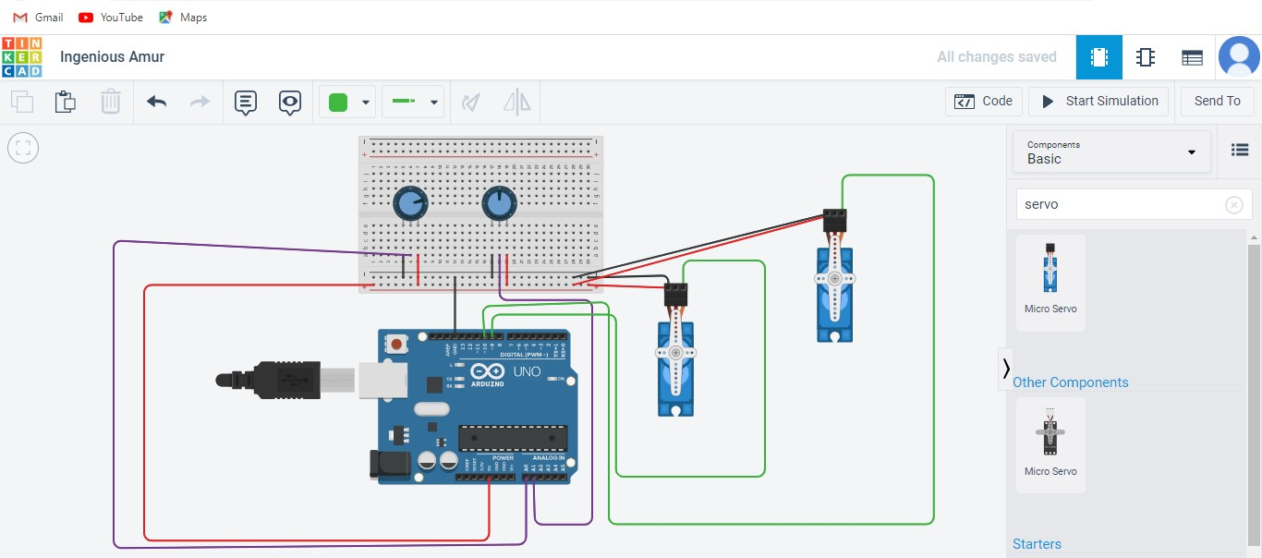

**Code:**

**#include <Servo.h>**

**int sensorValue = 0;**

**int outputValue = 0;**

**int sensorValue1 = 0;**

**int outputValue1 = 0;**

**Servo servo_9;**

**Servo servo_10;**

**void setup()**

**{**

**pinMode(A0, INPUT);**

**servo_9.attach(9, 500, 2500);**

**pinMode(A1, INPUT);**

**servo_10.attach(10, 500, 2500);**

**}**

**void loop()**

**{**

**sensorValue = analogRead(A0);**

**outputValue = map(sensorValue, 0, 1023, 0, 180);**

**servo_9.write(outputValue);**

**delay(10); // Delay a little bit to improve simulation performance**

**sensorValue1 = analogRead(A1);**

**outputValue1 = map(sensorValue1, 0, 1023, 0, 180);**

**servo_10.write(outputValue1);**

**delay(10); // Delay a little bit to improve simulation performance**

**}**

**Output:**

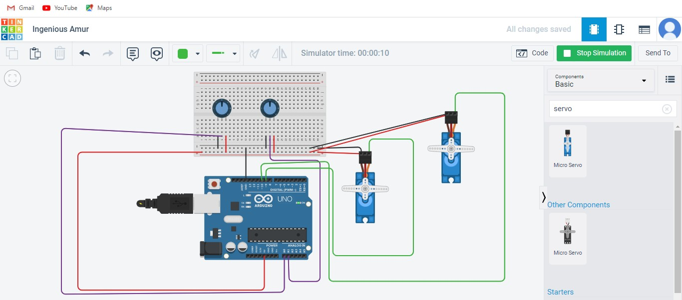

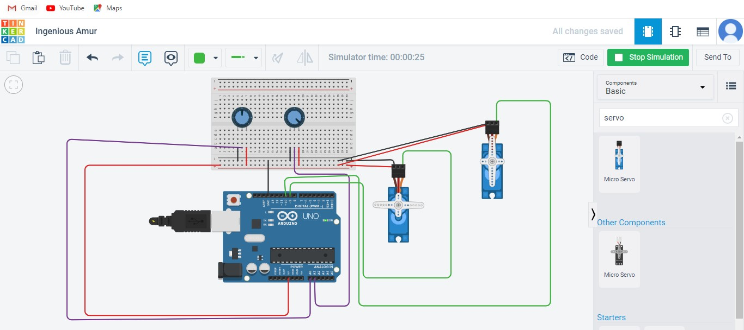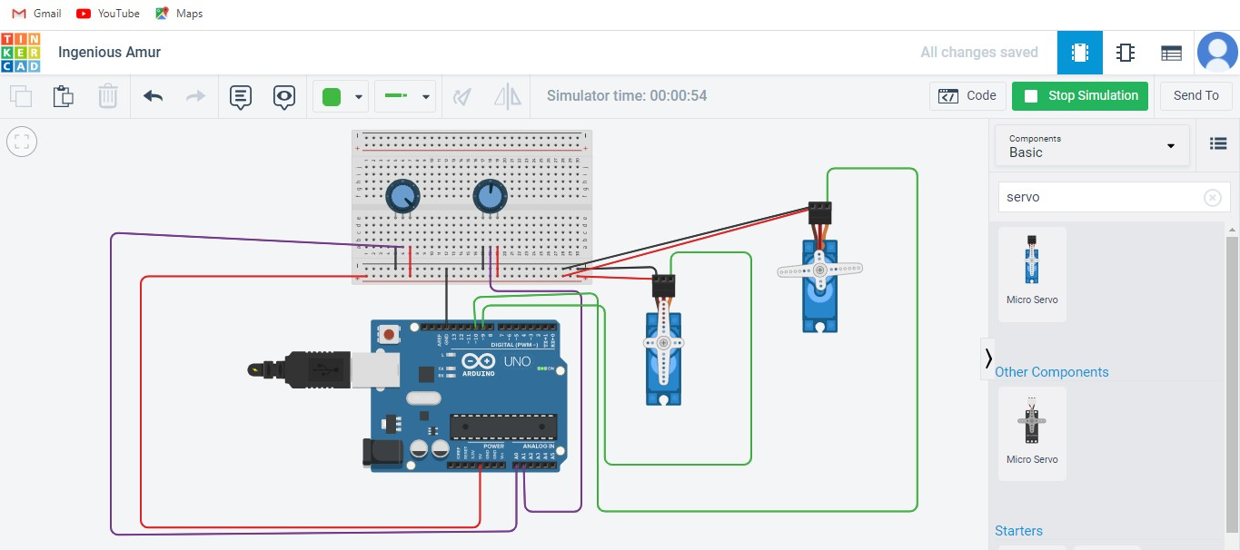

**PRACTICAL 7**

**Aim: Create an obstacle avoidance behaviour for robot and test it.**

**CODE**

**Part A**

**Take DC Motor and 9 Volt Battery, 2 Dc motors, Arduino UNO R3, 9V Battery and Breadboard small: Connect wires:**

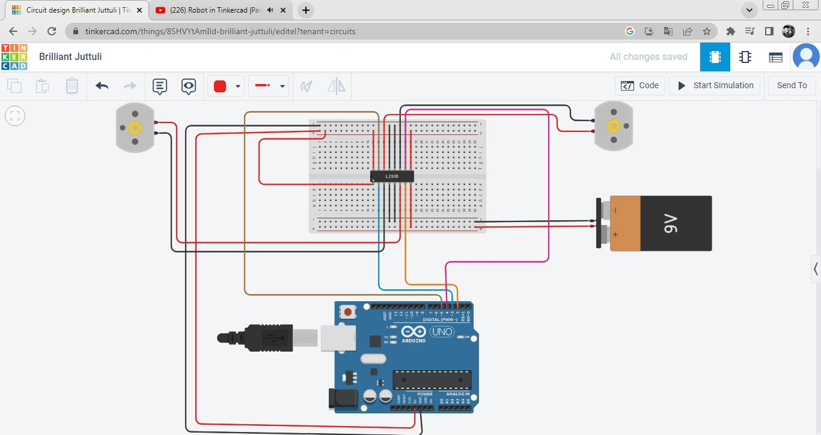

**Output:**

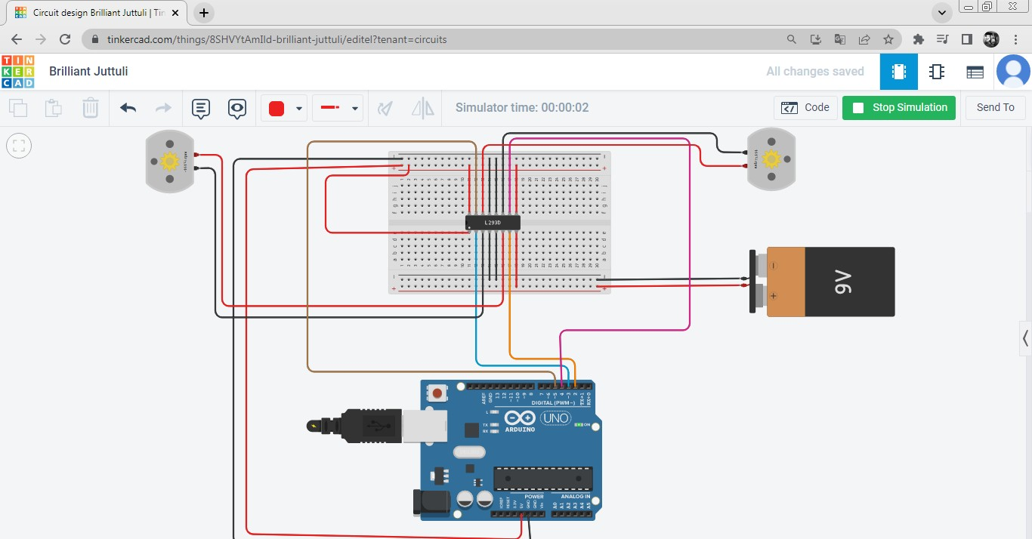

**Take 2 more motors & connect wires:**

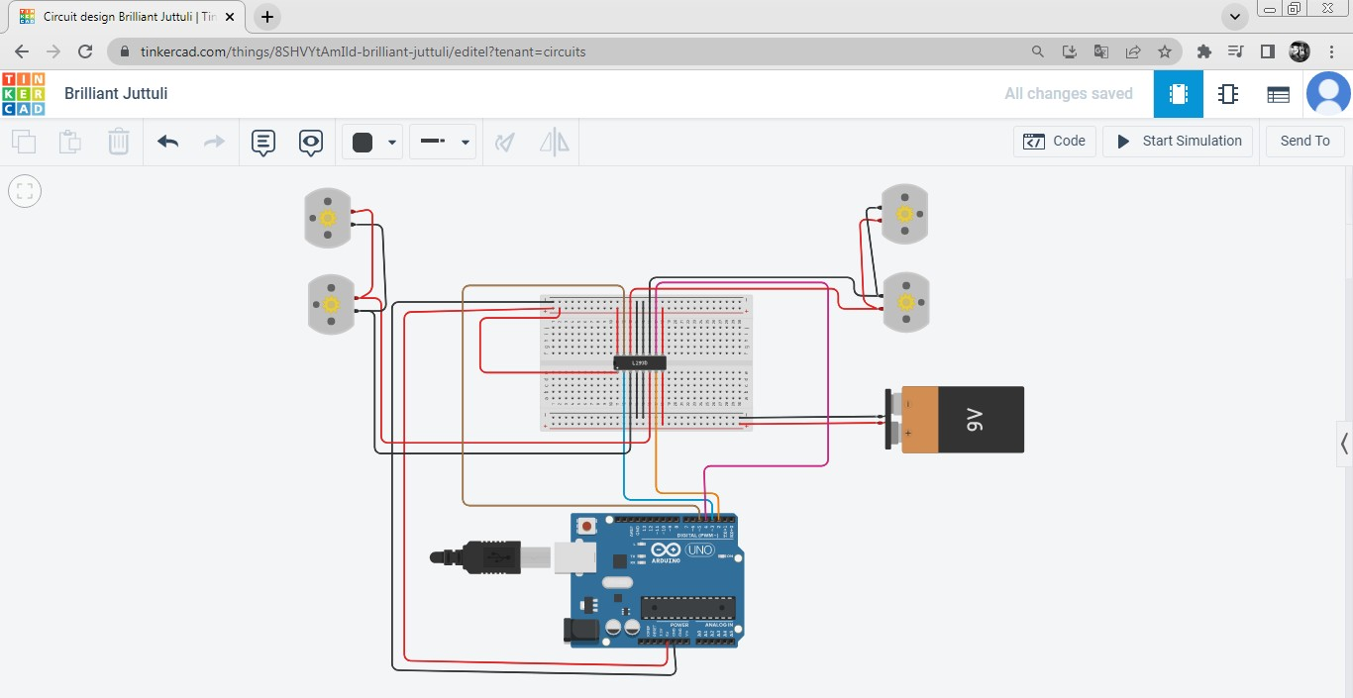

**Output:**

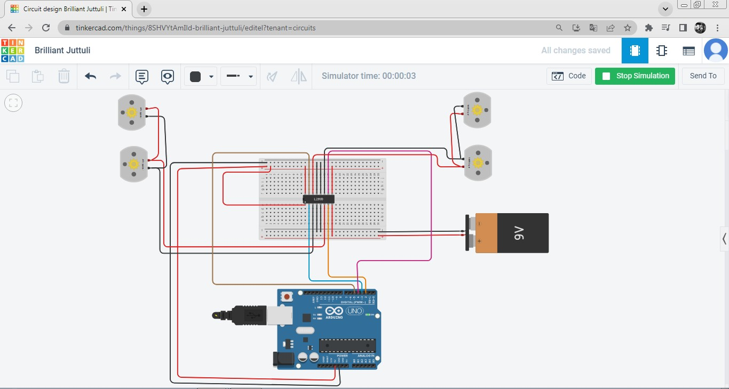

**Part B]**

**Take ultrasonic distance and connect :**

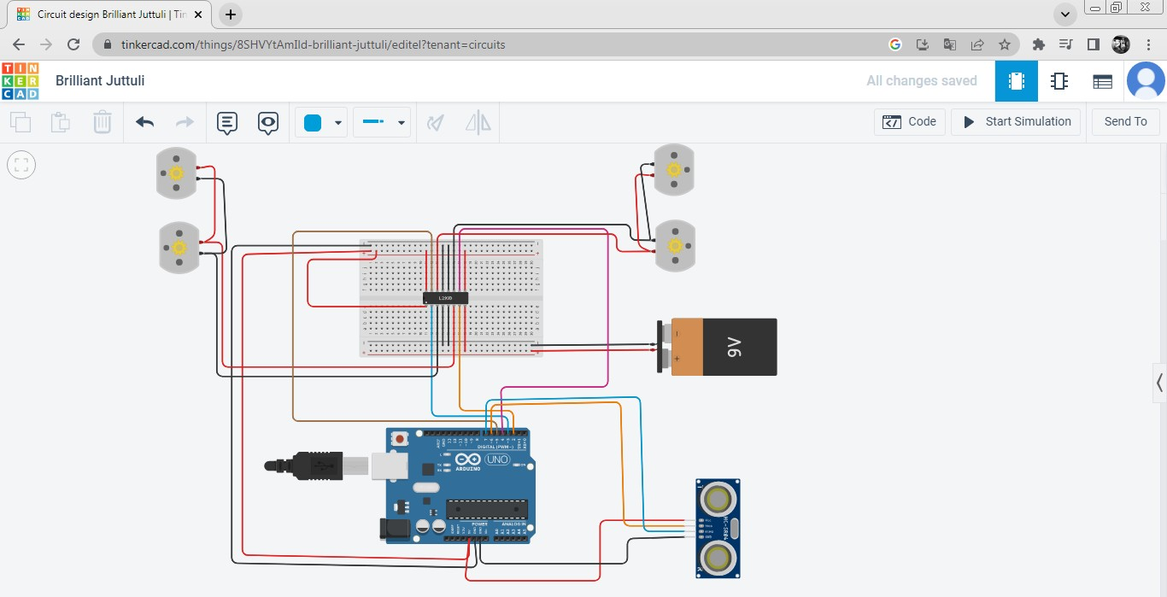

**Take LCD, Potentiometer and connect devices:**

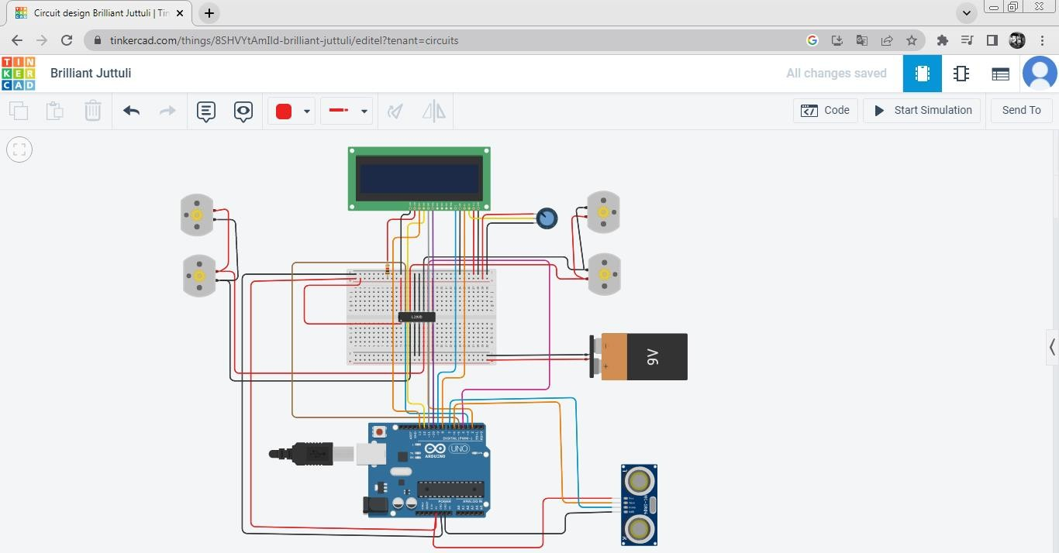

**Take resistor and connect:**

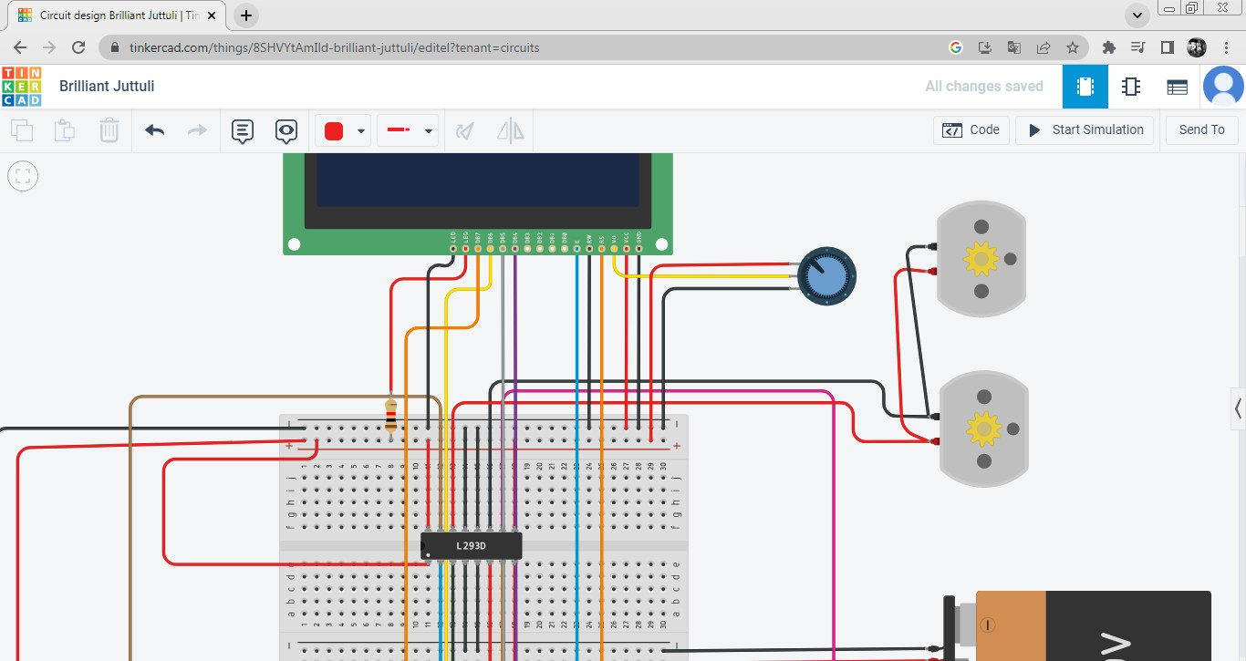

**Write code:**

**//code for obstacle avoiding robot**

**#include <LiquidCrystal.h>**

**LiquidCrystal lcd(8,9,10,11,12,13);**

**long cm, duration;**

**const int echoPin = 7;**

**const int trigPin = 6;**

**const int lm1 = 2;**

**const int lm2 = 3;**

**const int rm1 = 4;**

**const int rm2 = 5;**

**void setup()**

**{**

**pinMode(lm1, OUTPUT);**

**pinMode(lm2, OUTPUT);**

**pinMode(rm1, OUTPUT);**

**pinMode(rm2, OUTPUT);**

**pinMode(trigPin, OUTPUT);**

**pinMode(echoPin, INPUT);**

**Serial.begin(9600);**

**lcd.begin(16,2);**

**}**

**void loop()**

**{**

**digitalWrite(trigPin, LOW);**

**delayMicroseconds(2);**

**digitalWrite(trigPin, HIGH);**

**delayMicroseconds(5);**

**digitalWrite(trigPin, LOW);**

**duration = pulseIn(echoPin,HIGH);**

**//converting time into distance in centimetre**

**cm = duration*0.034/2;**

**if(cm < 20)**

**{**

**stop_bot();**

**delay(2000);**

**go_back();**

**delay(2000);**

**stop_again();**

**delay(1000);**

**go_left();**

**delay(1000);**

**}**

**else**

**{**

**go_straight();**

**delay(1000);**

**}**

**Serial.print("Distance:CM");**

**Serial.println(cm);**

**}**

**void go_straight()**

**{**

**lcd.setCursor(0,0);**

**lcd.print("NOTHING AHEAD");**

**lcd.setCursor(0,1);**

**lcd.print("MOVING FORWARD");**

**digitalWrite(lm1,HIGH);**

**digitalWrite(lm2,LOW);**

**digitalWrite(rm1,HIGH);**

**digitalWrite(rm2,LOW);**

**}**

**void go_back()**

**{**

**lcd.clear();**

**lcd.setCursor(0,0);**

**lcd.print("TAKING REVERSE");**

**lcd.setCursor(0,1);**

**lcd.print(cm);**

**digitalWrite(lm2,HIGH);**

**digitalWrite(lm1,LOW);**

**digitalWrite(rm2,HIGH);**

**digitalWrite(rm1,LOW);**

**}**

**void stop_bot()**

**{**

**lcd.clear();**

**lcd.setCursor(0,0);**

**lcd.print("SOMETHING AHEAD");**

**lcd.setCursor(0,1);**

**lcd.print("STOP!");**

**digitalWrite(lm1,LOW);**

**digitalWrite(lm2,LOW);**

**digitalWrite(rm1,LOW);**

**digitalWrite(rm2,LOW);**

**}**

**void stop_again()**

**{**

**lcd.clear();**

**lcd.setCursor(0,0);**

**lcd.print("BREAK FOR TURN");**

**digitalWrite(lm1,LOW);**

**digitalWrite(lm2,LOW);**

**digitalWrite(rm1,LOW);**

**digitalWrite(rm2,LOW);**

**}**

**void go_left()**

**{**

**lcd.clear();**

**lcd.setCursor(0,0);**

**lcd.print("TURNING LEFT");**

**lcd.setCursor(0,1);**

**lcd.print(cm);**

**digitalWrite(lm1,LOW);**

**digitalWrite(lm2,LOW);**

**digitalWrite(rm1,HIGH);**

**digitalWrite(rm2,LOW);**

**}**

**void go_right()**

**{**

**lcd.clear();**

**lcd.setCursor(0,0);**

**lcd.print("TURNING RIGHT");**

**lcd.setCursor(0,1);**

**lcd.print(cm);**

**digitalWrite(lm1,HIGH);**

**digitalWrite(lm2,LOW);**

**digitalWrite(rm1,LOW);**

**digitalWrite(rm2,LOW);**

**}**

**OUTPUT:**

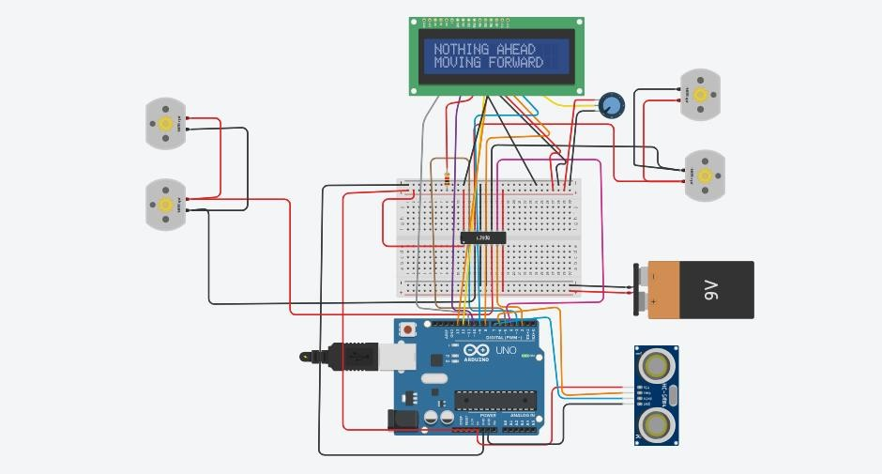

# **PRACTICAL 8**

**Aim: Detect faces with Haar cascades**

**CODE:**

**import cv2**

**from google.colab.patches import cv2_imshow**

**img = cv2.imread('test.jpg')**

**gray_img = cv2.cvtColor(img, cv2.COLOR_BGR2GRAY)**

**haar_cascade = cv2.CascadeClassifier(cv2.data.haarcascades +"haarcascade_frontalface_default.xml")**

**eye_cascade = cv2.CascadeClassifier(cv2.data.haarcascades + "haarcascade_eye.xml")**

**faces_rect = haar_cascade.detectMultiScale(gray_img, 1.3, 5)**

**eyes = eye_cascade.detectMultiScale(gray_img)**

**for (x, y, w, h) in faces_rect:**

**cv2.rectangle(img, (x, y), (x+w, y+h), (0, 255, 0), 2)**

**for (ex, ey, ew, eh) in eyes:**

**cv2.rectangle(img, (ex, ey), (ex+ew, ey+eh), (0, 255, 0), 2)**

**cv2_imshow(img)**

**OUTPUT:**

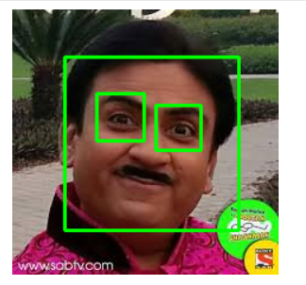

# **PRACTICAL 9**

**Aim: Running Mycroft Environment on Raspberry Pi 3**

# **Hardware Required**

* **Raspberry Pi 3 Model B / B+**
* **16 GB microSD card (minimum)**
* **5V 2.5A power adapter**
* **USB speaker + microphone combo o OR USB microphone + 3.5 mm speaker**
* **Internet connection**

# **Step 1: Install Raspberry Pi OS (Lite – Recommended)**

**Raspberry Pi 3 has limited RAM, so Lite OS works best.**

**1. Open Raspberry Pi Imager 2. Select:**

**o OS → Raspberry Pi OS Lite (64-bit) o Storage → microSD card**

1. **Click ⚙️:**

**o Enable SSH o Configure Wi-Fi**

1. **Flash OS and boot Raspberry Pi 3**

**Login:**

**username: pdl password: pdl**

# **Step 2: Connect Speaker & Microphone**

**Plug in your USB audio device.**

**Check detection:**

**arecord -l aplay -l**

**If devices appear → continue**

# **Step 3: Configure Audio (Very Important)**

**Open mixer:**

**alsamixer**

* **Press F6 → select USB audio • Increase: o Mic o Speaker**
* **Press M to unmute Test microphone:**

**arecord test.wav aplay test.wav**

**If you hear your voice → audio OK**

# **Step 4: Update Raspberry Pi**

**sudo apt update && sudo apt upgrade -y sudo reboot**

# **Step 5: Install Mycroft Environment (OVOS – Lightweight Mode)**

**Install required dependencies sudo apt install -y git python3 python3-pip python3-venv portaudio19-dev**

**Install OpenVoiceOS Core (Optimized for Pi 3)**

**git clone https://github.com/OpenVoiceOS/ovos-core.git cd ovos-core python3 -m venv .venv source .venv/bin/activate pip install --upgrade pip pip install ovos-core[extras]**

**Takes 15–20 minutes on Pi 3 (Slow on Pi3)**

# **Step 6: Install Wake Word & TTS**

**pip install ovos-dinkum-listener ovos-tts-plugin-pico**

**Pico TTS is fast & lightweight (ideal for Pi 3).**

# **Step 7: Configure Audio & Wake Word**

**Create config:**

**mkdir -p ~/.config/OpenVoiceOS**

**nano ~/.config/OpenVoiceOS/mycroft.conf**

**Paste:**

**{**

**"listener": {**

**"wake_word": "hey mycroft"**

**},**

**"tts": {**

**"module": "ovos-tts-plugin-pico"**

**},**

**"audio": {**

**"input": {**

**"device": "default"**

**},**

**"output": {**

**"device": "default"**

**}**

**}**

**}**

**Save → CTRL+X, Y, ENTER**

# **Step 8: Start Mycroft Services**

**Activate environment: source ~/ovos-core/.venv/bin/activate**

**Start voice assistant:**

**ovos-core Say:**

**“Hey Mycroft, what is the time?”**

**You should hear a response**

# **Step 9: Auto-Start on Boot (Optional but Recommended)**

**Create service:**

**sudo nano /etc/systemd/system/ovos.service**

**Paste:**

**[Unit]**

**Description=OpenVoiceOS (Mycroft)**

**After=network.target sound.target**

**[Service]**

**User=pi**

**ExecStart=/home/pi/ovos-core/.venv/bin/ovos-core WorkingDirectory=/home/pi/ovos-core**

**Restart=always**

**[Install]**

**WantedBy=multi-user.target Enable:**

**sudo systemctl daemon-reload sudo systemctl enable ovos**

**sudo systemctl start ovos**

# **Block Diagram**

**USB Microphone**

**↓**

**Raspberry Pi 3**

**(Mycroft / OpenVoiceOS)**

**↓**

**Speaker**

**PRACTICAL 10**

**Aim: Use the robot to display its camera as a web app on a phone or desktop**

